# DELHI TECHNOLOGICAL UNIVERSITY

# INNOVATIVE PROJECT REPORT

**MUSIC(FEC24)**

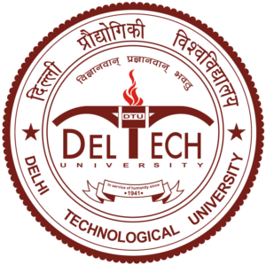

Submitted to – Prof. Vandana sharma

Submitted by – Ritik Singh (2K19/CO/319)

**DELHI TECHNOLOGICAL UNIVERSITY**

**(Formerly Delhi College of Engineering)**

**Bawana Road, Delhi – 110042**

# TYAGARAJA

# 12-Tyagaraja

# **The embodiment of Carnatic music**

**Acknowledgement**

I express my sincere gratitude to Prof Vandana Sharma to encourage me to the highest peak and to provide me the opportunity to prepare my project. I am immensely obliged to my friends for their elevatingbinspiration, kind supervision and encouragement throughout the project.

Last but not the least, I thank my parents for sharing their wisdom with me and giving constant support always.

**Introduction**

Every genre of music has its influencers and demigods. Some of them change the course of history. In Western classical, you have Beethoven and Mozart. In Hindustani music, you have the Sufi saint Amir Khusrau and Miyan Tansen from Akbar’s court. But Carnatic music can be divided simply into two eras: pre-Tyagaraja and post-Tyagaraja. Tyagaraja (1767–1847) is indisputably the most celebrated poet-composer and singer in Carnatic music. 2017 marks his 250th birth anniversary year.

Tyagaraja was born to Kakarla Tamabrahmam and Sitamma on 14th May 1767 in the village of Thiruvayaru in the Thanjavur district of Tamil 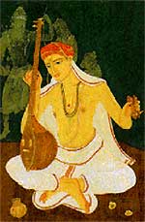Nadu .What we know is that he began his musical training at an early age under music scholar Sonti venkata Ramanayya who was impresses by the child prodigy.

With the influence of Ramayana, he became a devotee of Lord Sri Rama.In his praise and honour he wrote numerous musical operas, and about twenty four thousand songs, a claim that has been speculated among music historians.He regarded music as a way to experience God’s love. His compositions focused on expression, rather than on the technicalities of classical music.

In his teens, he composed his first song, "Namo Namo Raghavayya", in the Desika Todi [ragam](https://en.wikipedia.org/wiki/Ragam" \o "Ragam) and inscribed it on the walls of the house. Tyagaraja himself had several illustrious students who took his musical legacy ahead.

**Specialization**

Tyagaraja’s songs and compositions are full of devotion to his god Rama.To him music was so creative that he could not be bound in mere traditional grammar. He saw the potentiality in new melodies and from them gave forms to ragas like Kharaharapriya, Harikambhoji and Deyagandhari. He must have breathed life into such simple tunes to make them into ragas.

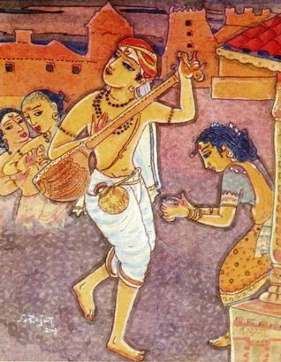He says that we should worship the beauty of the seven swaras and that each raga has incarnated as a beautiful damsel dancing with tinkling bells. In ‘Ninnu vina sukhamu gaana,’ he describes Rama as ‘raga rasika’ and in ‘Manamu leda,’ he asks Rama why, in spite of knowing the appeal of music and being the father of the musicians — Lava and Kusa, he is indifferent towards a musician like Tyagaraja. In ‘Gitartamu,’ Tygaraja says that Hanuman resorted to Rama because, he himself being an authority on music, knew that Rama represented the essence of Gita and Sangita.

Usually, Tyagaraja used to sing his compositions sitting before deity manifestations of Lord Rama, and his disciples noted down the details of his compositions on palm leaves. After his death, these were in the hands of his disciples, then families descending from the disciples. There was not a definitive edition of Tyagaraja's songs.

Out of the more than 200 ragas handled by him, in nearly half there is no kriti other than Tyagaraja’s. Andolika, Nalinakanti and Bahudari, which were considered rare in his days, are today instantly recognisable by most listeners thanks to the ‘draksha rasa’ (surface sweetness) structure of his kritis in these ragas.

**Contribution**

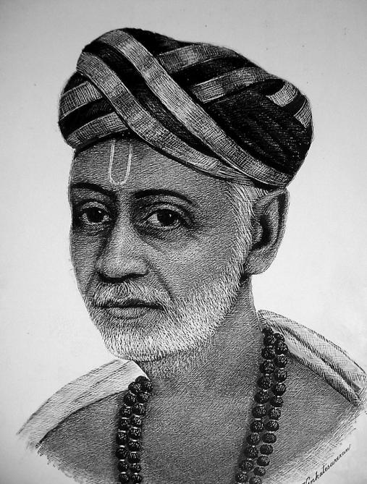A Carnatic music concert anywhere in the world is incomplete without Thyagaraja’s compositions. Popularly known as Sangeeta Brahma, Saint Thyagaraja is an 18th century Carnatic Music Composer, of both in Telugu and Sanskrit, who greatly influenced the development of classical music tradition with his finest compositions (like Pancharatna kriti etc.).

He regarded music as a way to experience God's love, and portrays Lord Rama’s emotions. His compositions are simple and it is how he manages to relate his feelings to the audience that truly intrigues. His objective was purely devotional, and not on the technicalities of classical music or to record them. Hence his musical output, almost in all ragas, is sparsely codified. About 24,000 songs, comparable to the number of slokas in Valmiki’s Ramayana, is said to have been composed by him and only about 700 songs remain today.

He introduced the concept of 'Sangati' which means variations on melodic line of a composition. Also, he showed the world that nadopasana (devotion through music) involving nada yoga(science of sound vibrations) is a veritable means to salvation.

Thyagaraja Aradhana, a week-long commemorative annual music festival is held in his honour, where thousands of Carnatic musicians from all over the world converge. Also, a crater on the planet Mercury is named 'Thyagaraja' in his honour.

**Conclusion**

Tyagaraja contributed immensely to Carnatic music and the Indian classical music culture, his work will undoubtedly go down as one the most prolific and profound ones in the history of mankind.

Also, it won’t be an exaggeration to say that he was and is one of the greatest musician the world has ever seen and will always be remembered with great respect, admiration and love.

